**Jesus calls the disciples**

**Reading: Luke 5:1-11**

One day Jesus was standing by the Sea of Galilee. The people crowded round him and listened to the word of God. Jesus saw two boats at the edge of the water. They had been left there by the fishermen, who were washing their nets. He got into the boat that belonged to Simon. Jesus asked him to go out a little way from the shore. Then he sat down in the boat and taught the people.

When he finished speaking, he turned to Simon. Jesus said, “Go out into deep water. Let down the nets so you can catch some fish.” Simon answered, “Master, we’ve worked hard all night and haven’t caught anything. But because you say so, I will let down the nets.”

When they had done so, they caught a large number of fish. There were so many that their nets began to break.

When Simon Peter saw this, he fell at Jesus’ knees. “Go away from me, Lord!” he said. “I am a sinful man!” He and everyone with him were amazed at the number of fish they had caught.

Then Jesus said to Simon “Don’t be afraid. From now on you will fish for people.” So they pulled their boats up on shore. Then they left everything and followed him.

**Thought about the reading**

In the story today we meet Simon Peter and his friends, James and John. They were fishermen, ordinary hard-working people. Jesus chose these people to be his disciples, his special friends, who went with him as he travelled around the country preaching and healing people. He was also training them to lead his church after he returned to heaven.

They had been fishing all night and caught nothing. They must have been very tired and disappointed. No fish meant no food to eat! Jesus told them to try one more time and they caught so many fish that the nets began to break! It was a miracle!

Simon Peter realised that Jesus was someone very special. He did not feel good enough to follow him. But Jesus told him not to be afraid. So they left everything to follow him. Their lives were changed for ever.

Jesus calls us to follow him. We may feel that we are not good enough, but he says to us, “Don’t be afraid.” Are we ready to say ‘Yes’ to Jesus?

**Prayer**

Dear Jesus, thank you that you are calling me to follow you. Help me not to be afraid, but to say ‘Yes’ to you.

Amen

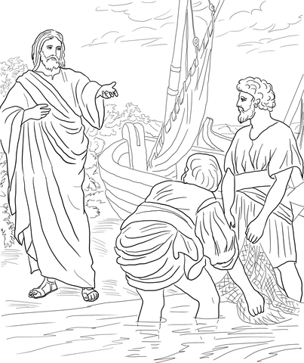

**Cambridge Causeway**

Spring 2025

Bible Study notes

**People changed by Jesus**

**6. Jesus calls the disciples**

By Chrissy Cole